1.class Solution {
public boolean halvesAreAlike(String s) {
int n = s.length();
String a = s.substring(0, n / 2);
String b = s.substring(n / 2)
return countVowels(a) == countVowels(b);
}
private int countVowels(String str) {
int count = 0;
for (char c : str.toCharArray()) {
if (isVowel(c)) {
count++;
}
}
return count;
}
private boolean isVowel(char c) {
return "aeiouAEIOU".indexOf(c) != -1;
}
}

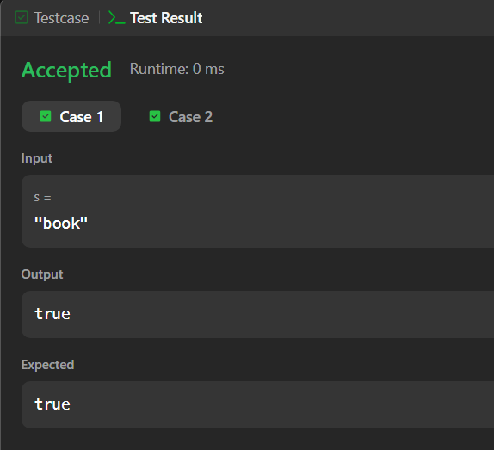import

2. class Lapindrome {
public static void main(String[] args) {
Scanner sc = new Scanner(System.in);
int T = sc.nextInt();
while (T-- > 0) {
String s = sc.next();
if (isLapindrome(s)) {
System.out.println("YES");
} else {
System.out.println("NO");
}
}
}
private static boolean isLapindrome(String s) {
int n = s.length();
String left, right;
if (n % 2 == 0) {
left = s.substring(0, n / 2);
right = s.substring(n / 2);
} else {
left = s.substring(0, n / 2);
right = s.substring(n / 2 + 1);
}
return getFrequency(left).equals(getFrequency(right));
}

private static Map<Character, Integer> getFrequency(String str) {
Map<Character, Integer> freq = new HashMap<>();
for (char c : str.toCharArray()) {
freq.put(c, freq.getOrDefault(c, 0) + 1);
}
return freq;
}
}import java.util.*;
class Lapindrome {
public static void main(String[] args) {
Scanner sc = new Scanner(System.in);
int T = sc.nextInt()
while (T-- > 0) {
String s = sc.next();
if (isLapindrome(s)) {
System.out.println("YES");
} else {
System.out.println("NO");
}
}
}
private static boolean isLapindrome(String s) {
int n = s.length();
String left, right;

if (n % 2 == 0) {
left = s.substring(0, n / 2);
right = s.substring(n / 2);
} else {
left = s.substring(0, n / 2);
right = s.substring(n / 2 + 1);
}
return getFrequency(left).equals(getFrequency(right));
}
private static Map<Character, Integer> getFrequency(String str) {
Map<Character, Integer> freq = new HashMap<>();
for (char c : str.toCharArray()) {
freq.put(c, freq.getOrDefault(c, 0) + 1);
}
return freq;
}
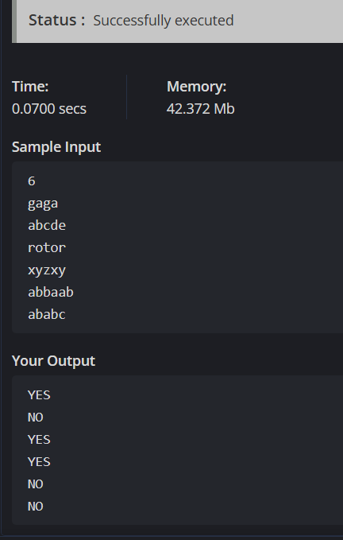

import java.util.*;
public class Solution {
public static void main(String[] args) {
Scanner sc = new Scanner(System.in);
int[] a = new int[3];
int[] b = new int[3];
// Read Alice's ratings
for (int i = 0; i < 3; i++) {
a[i] = sc.nextInt();
}
for (int i = 0; i < 3; i++) {
b[i] = sc.nextInt();
}
int alicePoints = 0;
int bobPoints = 0;
for (int i = 0; i < 3; i++) {
if (a[i] > b[i]) {
alicePoints++;
} else if (a[i] < b[i]) {
bobPoints++;
}
}
System.out.println(alicePoints + " " + bobPoints);
}
}import java.util.*;

4.class Solution {
public boolean containsDuplicate(int[] nums) {
Set<Integer> seen = new HashSet<>();

for (int num : nums) {
if (seen.contains(num)) {
return true; // Duplicate found
}
seen.add(num);
}
return false; // No duplicates
}
}
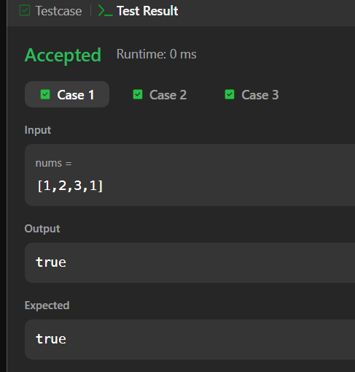
5. import java.util.*;
public class Solution {
public static String timeConversion(String s) {
// Extract hour, minutes, seconds, and AM/PM
String ampm = s.substring(8); // AM or PM
int hour = Integer.parseInt(s.substring(0, 2));
String minutesSeconds = s.substring(2, 8); // :MM:SS
if (ampm.equals("AM")) {
if (hour == 12) {
hour = 0; // Midnight case
}
} else { // PM case
if (hour != 12) {
hour += 12; // Convert to 24-hour format
}
}
return String.format("%02d%s", hour, minutesSeconds);
}
public static void main(String[] args) {
Scanner sc = new Scanner(System.in);
String s = sc.next();
System.out.println(timeConversion(s));
}
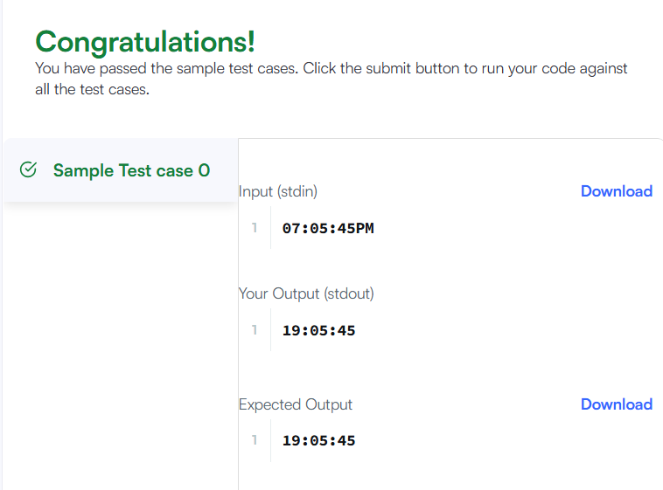

6. class Solution {
public void moveZeroes(int[] nums) {
int pos = 0; // position to place next non-zero
for (int i = 0; i < nums.length; i++) {
if (nums[i] != 0) {
nums[pos] = nums[i];
pos++;
}
}
while (pos < nums.length) {
nums[pos] = 0;
pos++;
}
}
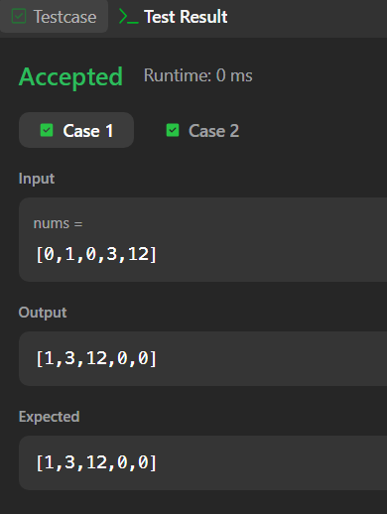

7. import java.util.*;
public class Solution {
public static int diagonalDifference(List<List<Integer>> arr) {
int n = arr.size();
int primarySum = 0;
int secondarySum = 0;
for (int i = 0; i < n; i++) {
primarySum += arr.get(i).get(i); // primary diagonal
secondarySum += arr.get(i).get(n - i - 1); // secondary diagonal
}
return Math.abs(primarySum - secondarySum);
}
public static void main(String[] args) {
Scanner sc = new Scanner(System.in);
int n = sc.nextInt();
List<List<Integer>> arr = new ArrayList<>();
for (int i = 0; i < n; i++) {
List<Integer> row = new ArrayList<>();
for (int j = 0; j < n; j++) {
row.add(sc.nextInt());
}
arr.add(row);
}
System.out.println(diagonalDifference(arr));
sc.close();
}
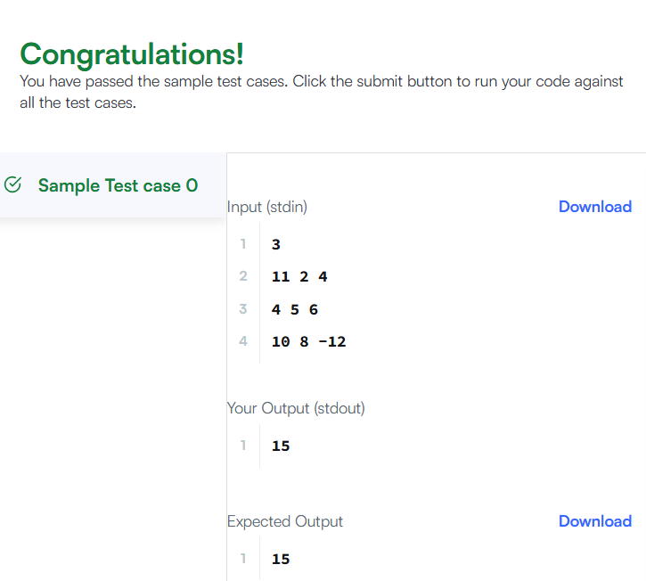
8. class Solution {
public int[][] transpose(int[][] matrix) {
int m = matrix.length; // number of rows
int n = matrix[0].length; // number of columns
int[][] result = new int[n][m]; // transposed matrix
for (int i = 0; i < m; i++) {
for (int j = 0; j < n; j++) {
result[j][i] = matrix[i][j];
}
}
return result;
}
}

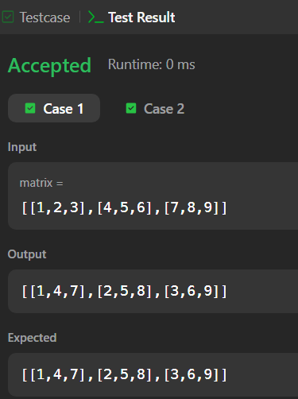

9. class Solution {
public int[][] matrixBlockSum(int[][] mat, int k) {
int m = mat.length, n = mat[0].length;
int[][] prefix = new int[m + 1][n + 1]; // extra row & col for easier boundaries
for (int i = 1; i <= m; i++) {
for (int j = 1; j <= n; j++) {
prefix[i][j] = mat[i - 1][j - 1]
+ prefix[i - 1][j]
+ prefix[i][j - 1]
- prefix[i - 1][j - 1];
}
}
int[][] ans = new int[m][n];
for (int i = 0; i < m; i++) {
for (int j = 0; j < n; j++) {
int r1 = Math.max(0, i - k);
int c1 = Math.max(0, j - k);
int r2 = Math.min(m - 1, i + k);
int c2 = Math.min(n - 1, j + k);
ans[i][j] = prefix[r2 + 1][c2 + 1]
- prefix[r1][c2 + 1]
- prefix[r2 + 1][c1]
+ prefix[r1][c1];
}
}
return ans;
}
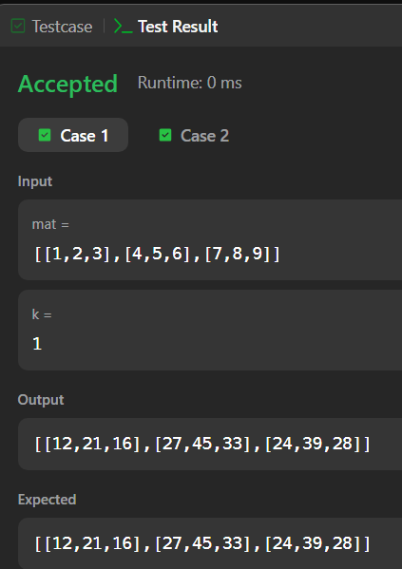
10. import java.util.*;

public class Solution {
public static void matrixRotation(int[][] matrix, int r) {
int m = matrix.length;
int n = matrix[0].length;
int layers = Math.min(m, n) / 2;

for (int layer = 0; layer < layers; layer++) {
List<Integer> elements = new ArrayList<>();

// Extract layer
for (int j = layer; j < n - layer; j++) elements.add(matrix[layer][j]); // top
for (int i = layer + 1; i < m - layer - 1; i++) elements.add(matrix[i][n - layer - 1]); // right
for (int j = n - layer - 1; j >= layer; j--) elements.add(matrix[m - layer - 1][j]); // bottom
for (int i = m - layer - 2; i > layer; i--) elements.add(matrix[i][layer]); // left

int len = elements.size();
int rot = r % len;

// Rotate
List<Integer> rotated = new ArrayList<>();
rotated.addAll(elements.subList(rot, len));
rotated.addAll(elements.subList(0, rot));

// Put back
int idx = 0;
for (int j = layer; j < n - layer; j++) matrix[layer][j] = rotated.get(idx++); // top
for (int i = layer + 1; i < m - layer - 1; i++) matrix[i][n - layer - 1] = rotated.get(idx++); // right
for (int j = n - layer - 1; j >= layer; j--) matrix[m - layer - 1][j] = rotated.get(idx++); // bottom
for (int i = m - layer - 2; i > layer; i--) matrix[i][layer] = rotated.get(idx++); // left
}

// Print result
for (int i = 0; i < m; i++) {
for (int j = 0; j < n; j++) {
System.out.print(matrix[i][j] + " ");
}
System.out.println();
}
}
public static void main(String[] args) {
Scanner sc = new Scanner(System.in);
int m = sc.nextInt();
int n = sc.nextInt();
int r = sc.nextInt();
int[][] matrix = new int[m][n];
for (int i = 0; i < m; i++) {
for (int j = 0; j < n; j++) {
matrix[i][j] = sc.nextInt();
}
}
matrixRotation(matrix, r);
sc.close();
}
}
